Ranking

Dense rank

Rank

Rownumber

Department wise highes 2nd salary

In sql

select \* from (select e.\* ,dense rank() over( partition by depno order by salary desc)As drnk from employee e)A where A.drnk=2

1. Create source
2. Click on + select window

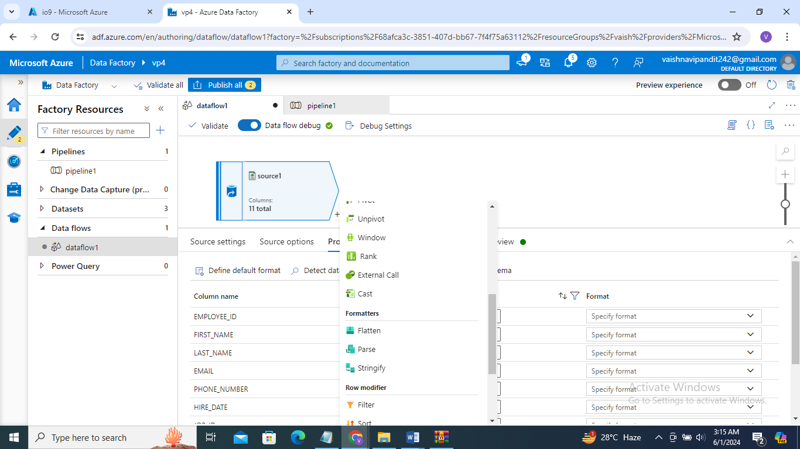

1. Go to window in over select department no,

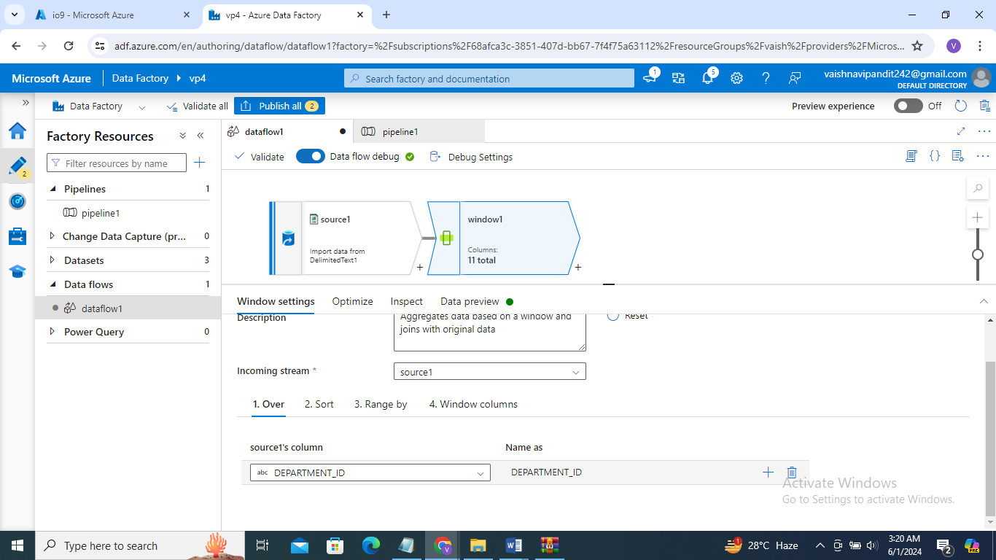

1. in sort select salary descending,

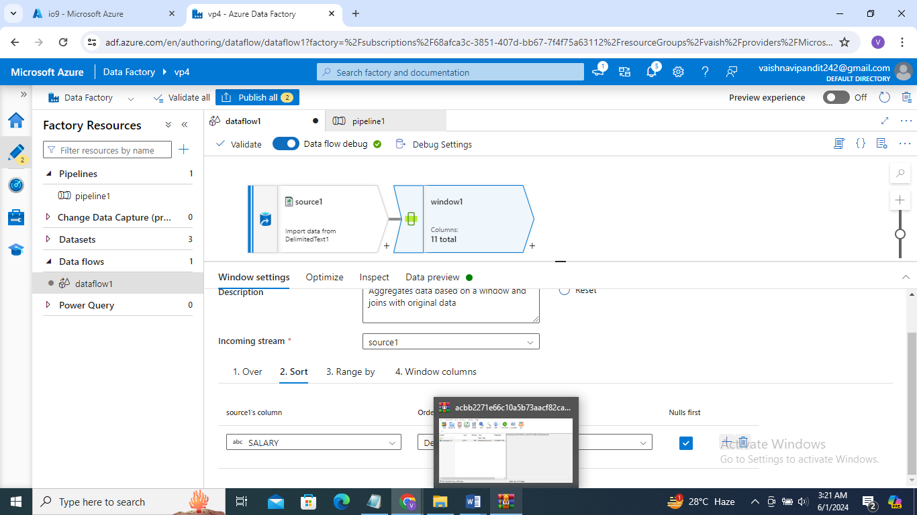

1. in window function column namr=drnk, expression dense rank()

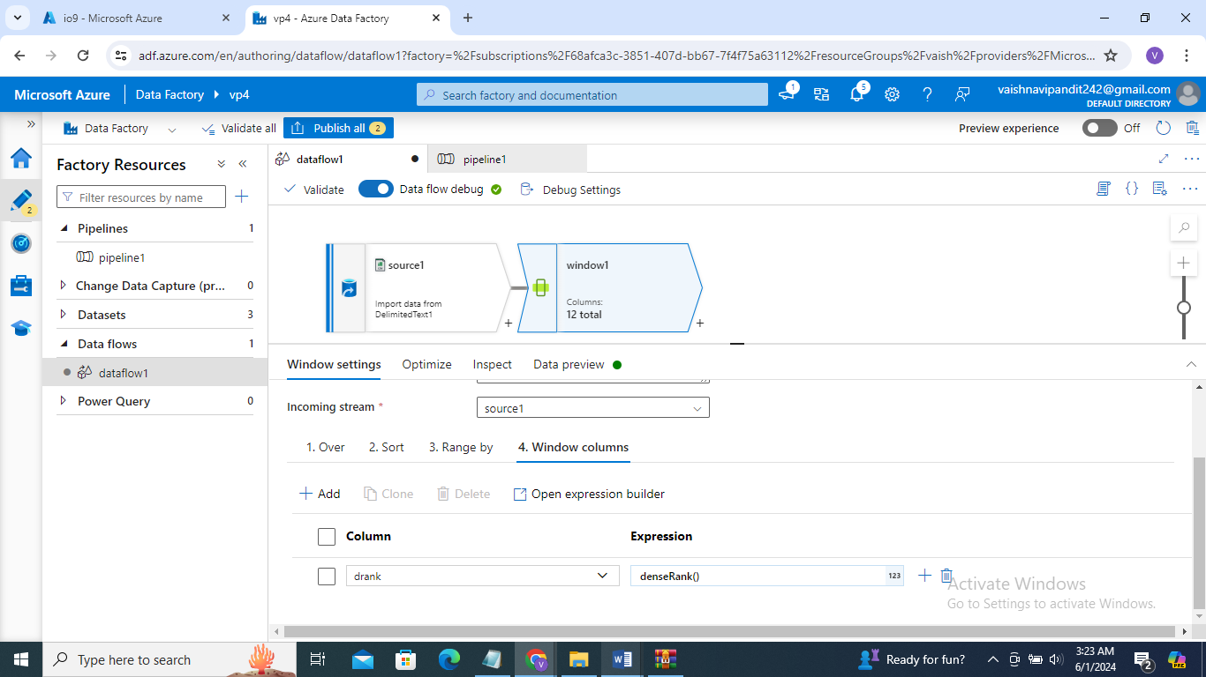

1. now click on + and select filter

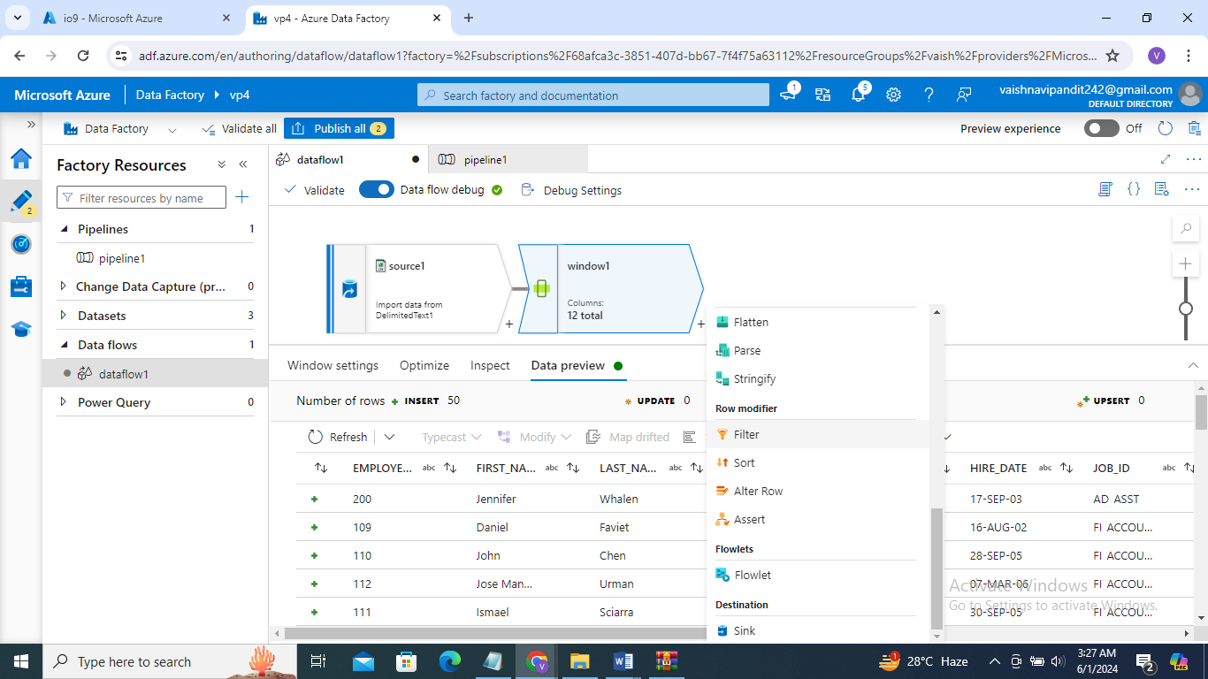

1. go to filter->filteron

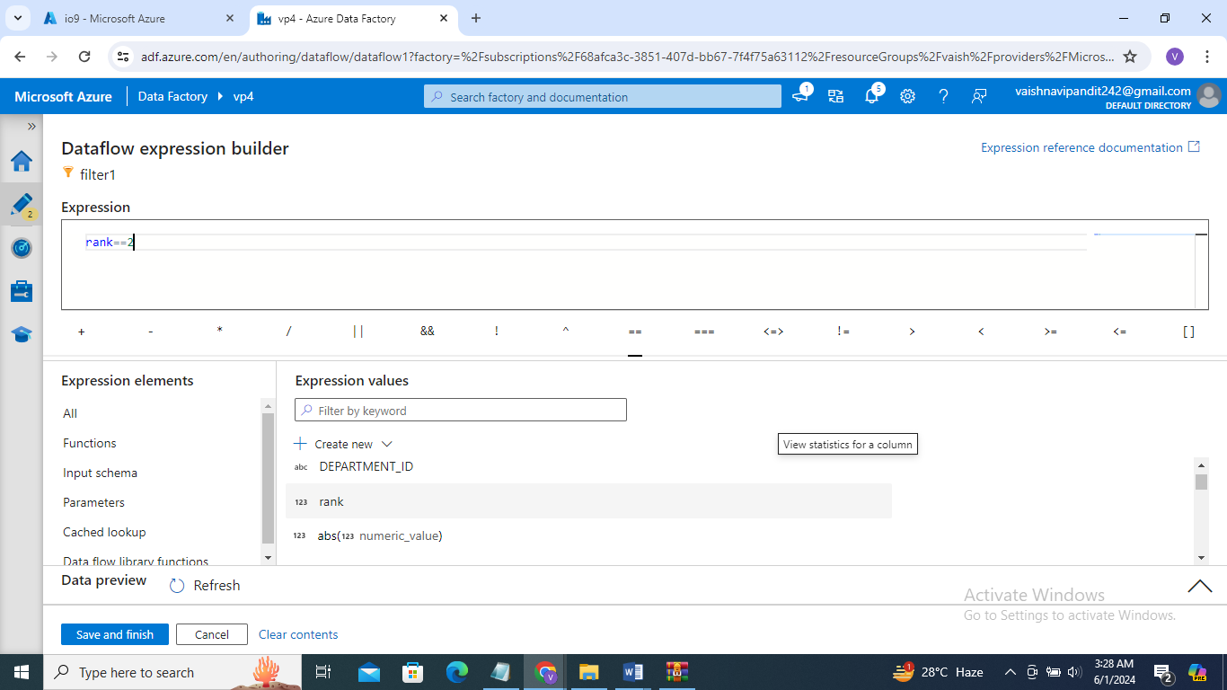

1. go see preview
2. we can do same with rank when partition by is not there go to + after source slect rank

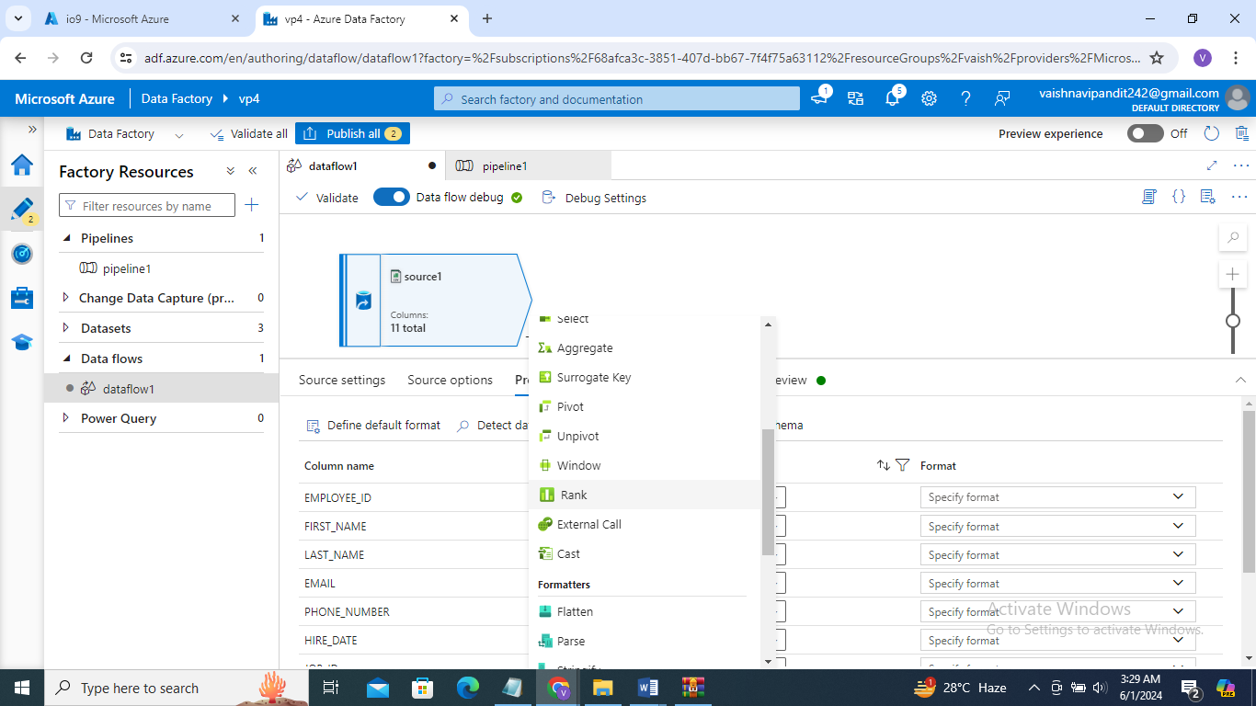

1. go to rank

ran column=rnk

sort condition salary=descending

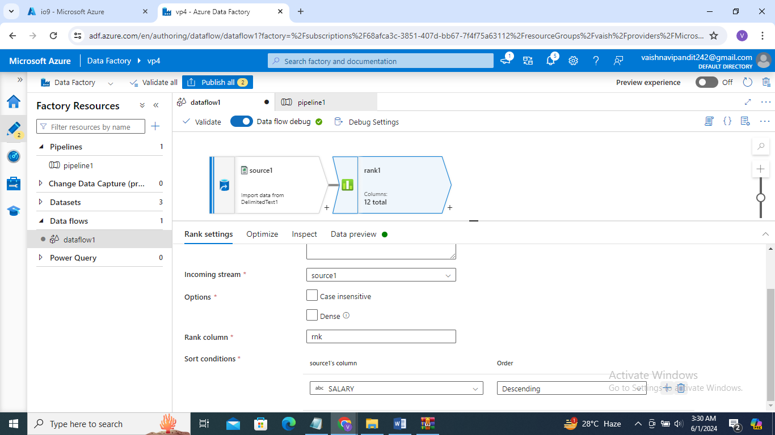

We can select dense also there

1. go see preview